**East West University**

**Lab Report**

**Semester:** Fall-2024

**Course Title:** Electronic Circuits **Course Code:** CSE251 **Sec:** 03

**Expt No**: 07

**Expt Name:** Biasing of a Common-Source Voltage Amplifier

**Group No:** 07

**Submitted by-**

Name: Sheikh Sarafat Hossain

Id: 2022-3-60-109

**Submitted to-**

Dr. Sarwar Jahan

Associate Professor

Department of Computer Science & Engineering

East West University

**Date of Performance:** 02-01-2025

**Date of Submission:** 16-01-2025

**Experiment Name:** Biasing of a Common-Source Voltage Amplifier

**Objectives:**

1. Identify an appropriate DC operation point for a NMOS transistor.

**Circuit Diagram:**

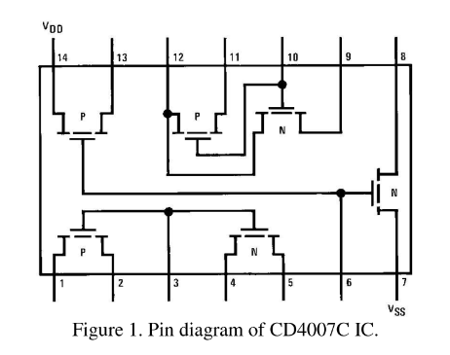 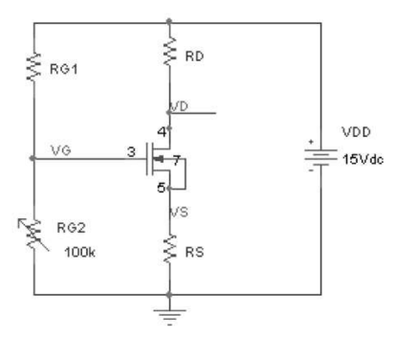

**Equipment and Components Needed:**

* Digital trainer board
* DC power supply
* Digital multimeter
* DC Voltmeter
* CD4007C IC (1 pc)
* Resistor (IKQ I pc)
* Breadboard
* Connecting wires

**Answer to the Lab Questions:**

Measured Resistance,

$R_{s}$ = 2.15 kΩ

$R_{G1}$ = 97.3 kΩ

$R_{G2}$ = 96.7 kΩ

$R_{D}$ = 3.28 kΩ

**(i)** For measured value,

$V_{DD}$ = 15V

VGS = 0.74V

VDS = 0.95V

Vt = 1.2 V

For saturation region,

$I_{D1}$ = $\frac{1}{2}k^{'}\left(\frac{w}{2}\right) {(V}_{ov}^{2})$

= $\frac{1}{2}×0.7×{\left(V_{GS}-V_{t}\right)}^{2}$

= $\frac{1}{2}×0.7×{(0.74- 1.2)}^{2}$

= 0.074mA

**(ii)** For Calculated value,

$V_{G}$ = 6.26V

VS = 5.52V

VDS = 0.95V

Vt = 1.2 V

$V_{D}$ = VDS +

*=* (0.95 + 5.52) V

= 6.47 V

VGS = VS

= (6.6 – 5.52) V

= 1.1 V

For saturation region,

=

=

=

=

= 3.5 10-3 mA

**Discussion:**

